Name: Thongphanh Duangboudda

Student ID: 1210079322

Date: November 29, 2018

**Instructions:** Congratulations, you made it to the end of the course! You should have at least six pages of your site completed by the time you submit this. Use the following to have a written discussion about your experience in the course and the final project.

**Before submitting this document and all of your project files, make sure you meet all of these requirements:**

* You have complete the “Final Submission and Discussion” worksheet.
* You have zipped up or compressed your final project folder (including all of your HTML, CSS, images, videos, etc.)
* You have one (1) home page and six (6) (but no more than eight (8)) content pages.
* **Each page** must contain appropriate text and images that provide information and value to the target audience.
* **Each page** must contain appropriate page titles.
* You must make use of the HTML5 tags (HEADER, NAV, MAIN, and FOOTER)
* You must include one (1) table utilizing data effectively (not per page).
* You must include one (1) video (you are not required to create the video, there are many sharable videos on the Web – chose one that is relevant to your project). The idea behind this is to use the <video> tag, so embedding all YouTube iFrames does not qualify (you can however just do 1 <video> tag and the rest YouTube embed iFrames – but make it easy for me to find the video using the <video> tag).
* You must include one (1) e-mail link.
* You must include one (1) external link (link to another page.
* **Each page** must contain appropriate description meta tags.
* You must include one (1) form (four (4) fields minimum. You do not need to setup the server side processing (since we really didn’t go over it in class). You can use **action=”#”**. Keep in mind, the form will not submit correctly when you hit the submit button. Additionally, you can use **action="http://webdevbasics.net/scripts/demo.php"** and it will accept any form fields you pass to it (keep in mind it won’t look right since it uses the pacific styling).
  + Form must reside on project site (linking to an external form is not allowed)
* You must include one (1) external style sheet (CSS) which contains a minimum of six (6) styles
* Do NOT screenshot the code because we can’t run the code. Save the file to yourasurite – Project – Submission 7 – Publish and Discuss Project.docx file and yourasurite – Project – Submission 7– Publish and Discuss Project.pdf file. Submit both files to Blackboard.
* Zip your FinalProject code folder and named it yourasurite-FinalProject.zip. Submit that zipped file to Blackboard too. Make sure you change “yourasurite” to yours asurite.

**Discussion Questions**

1. **Now that you are finished with your project, your original concept of your project might have changed a lot. Discuss in detail the differences between your initial project design and your final product. Why did you make these changes (if you had any)?**

I did not make a lot changes as I was planning to, because I started working on the final phrase too late. As result, I only added an contact page as recommended.

1. **Describe in detail why you chose the design layout you did. Are you happy with the outcome? Did you run into any issues with your design while developing your site? What did you do to overcome those issues? Would you do anything differently the next time you designed a website?**

My design was simple; it has header, navigation, content, and footer section. I placed navigation section on top left corner, since many people have read book, newspaper from top left corner; so most people are used to look at the top left. Therefore, top left corner is best place for navigation links.

Also, I put contents of the web page at the center of page, since we user click on the link, their attention should focus at the center of the screen.

1. **You likely encountered challenges while working on your final project. In detail, describe the challenges you encountered and what you did to overcome them.**

Time management was major factor, since it is at the end of the semester. Also, to produce contents or find a good content is challenging, since it is involved may aspects of consideration. For instance, what group of people I want to target, and find appropriate contents for that group.

1. **Describe several concepts that you learned during this course that you found interesting and useful. Where there any concepts that you wish more time was spent on? Is there anything you would have like to incorporate into your final project that wasn’t covered during this course?**  
     
     
   Making webpage responsive is big take away from this course; also, many css style sheet functionalities is key to make a webpage appropriate for age group. Moreover, when we move mouse over a picture, we can display a bigger version of that one. I think it is very engaging. Finally, web accessibility concepts is major concepts that I took away from this class. I think it is important to think for all kind and condition of people to benefit from our sites.
2. **OPTIONAL (NOT REQUIRED FOR THE CLASS OR FACTORED INTO YOUR GRADE): If you took advantage of the “Getting Online” video in the Week 6 / Chapter 12 folder and setup a domain and hosting, what were your thoughts on the process? Did you run into any issues? What domain did you pick? Did you upload your files? You may have already answered this in the update #2, but some students wait until the end to complete this.**
3. **While trying to be as objective and unbiased as possible, please go through and critique your own site using the attached rubric. In the student critique column, indicate which score you should receive for each category (outstanding, average, or needs improvement) and write a short (1 or two sentence max) justification of that score.**

I did a few things. Maybe max score is a B, and a C would be acceptable. I thought I would have more time to fix, but sometimes issues arise, and I did not work as hard as I would like to for the final week.

**Student Critique**

|  |  |  |  |  |
| --- | --- | --- | --- | --- |
|  | **Outstanding** | **Average** | **Needs Improvement** | **Student Critique** |
| **EXAMPLE** | You did everything! | You did a few things. | You did nothing… | Outstanding – I believe I did everything correctly because of x, y, and z. |
| **Discussion Questions: Answers** | Clearly and completely answered the questions. | Answers to questions could have been more complete or more clear. | Answers were missing. |  |
| **Discussion Questions: Mechanics** | Organized, neat in appearance, easy to read and understand. | Some improvement is needed in the organization or appearance and/or the document is not easy to read or understand. | Answers were missing. |  |
| **Visual Appeal** | Use of color, contrast, text, graphics is appealing to target audience | Appealing to target audience in all but one area. | Not appealing to target audience in more than one area |  |
| **Navigation** | Easy to use, consistent | Inconsistent or difficult to use | Missing |  |
| **Accessibility** | W3C Guidelines followed | Two or fewer instances where W3C guidelines are not followed | Three or more instances where W3C guidelines are not followed |  |
| **Page Titles/ Logo Area** | Descriptive and include the site/company name | -- | Missing or does not include the site/company name |  |
| **Table** | Present and correct syntax | -- | Missing or incorrect syntax |  |
| **Graphics** | Present and correct syntax | -- | Missing or incorrect syntax |  |
| **Video** | Present and correct syntax | -- | Missing or incorrect syntax |  |
| **E-mail Link** | Present and correct syntax | -- | Missing or incorrect syntax |  |
| **Outside Link** | Present and correct syntax | -- | Missing or incorrect syntax |  |
| **Meta tag** | Correct syntax (description meta tags), excellent selection of keywords and meaningful description | Correct syntax (description meta tags), adequate selection of keywords and description | Missing or incorrect syntax |  |
| **Form Coding** | Contains 4 or more form fields, correct syntax, and meaningful form element names | Does not contain the required 4 form fields, incorrect syntax, or names of fields don’t make sense. | Missing |  |
| **Form Processing** | Form uses # or the pacific.php script as the action. | -- | Form not configured correctly. |  |
| **XHTML Validation** | Required number of pages pass | Less than the required number of pages pass | No pages pass |  |
| **CSS Validation** | External CSS file is present and passes validation | External CSS file is present but does not pass validation | External CSS file is not present or does not pass validation |  |

**Web page browser view screenshot of Home Page**

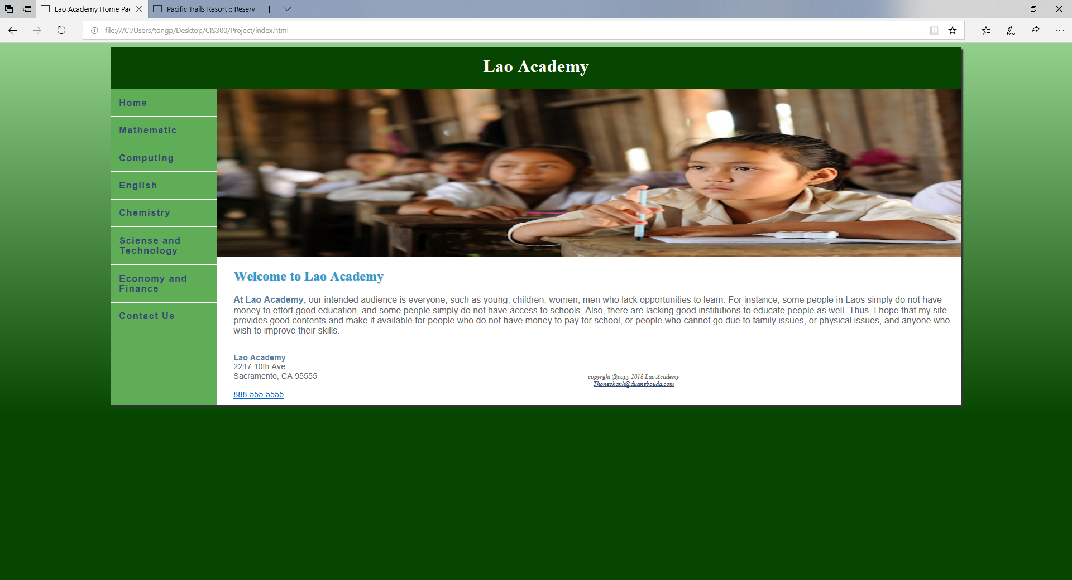

**Web page browser view screenshot of Page #1**

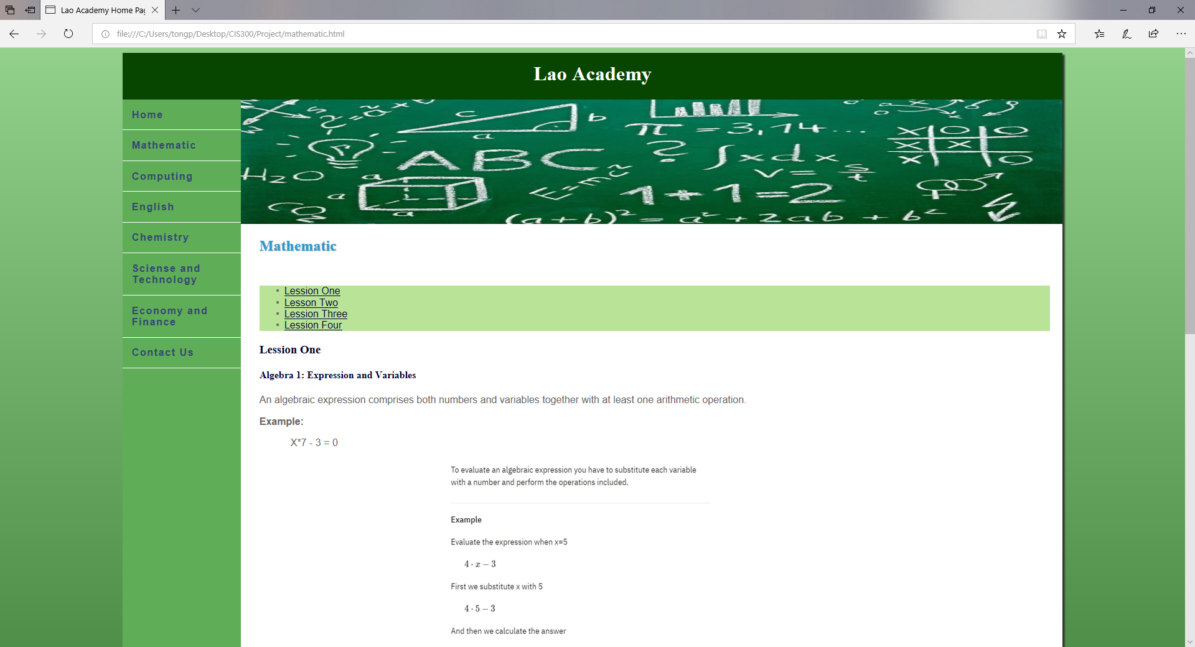

**Web page browser view screenshot of Page #2**

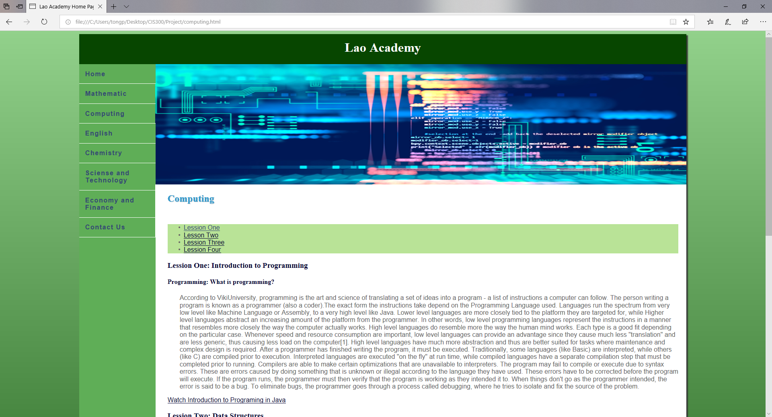

**Web page browser view screenshot of Page #3**

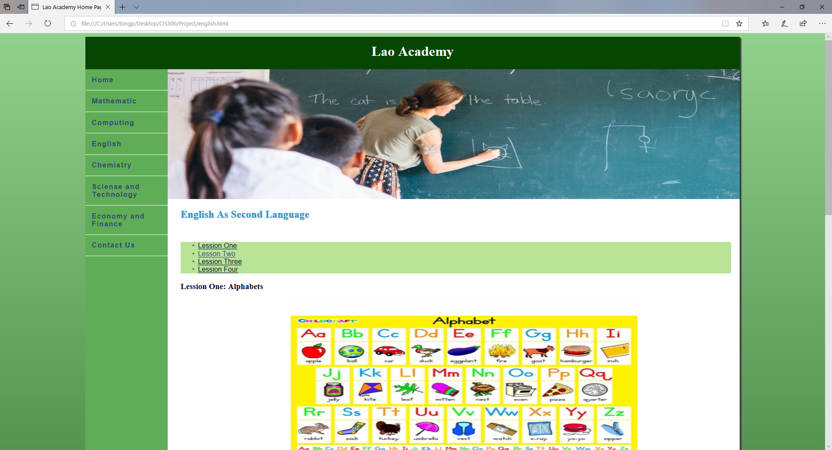

**Web page browser view screenshot of Page #4**

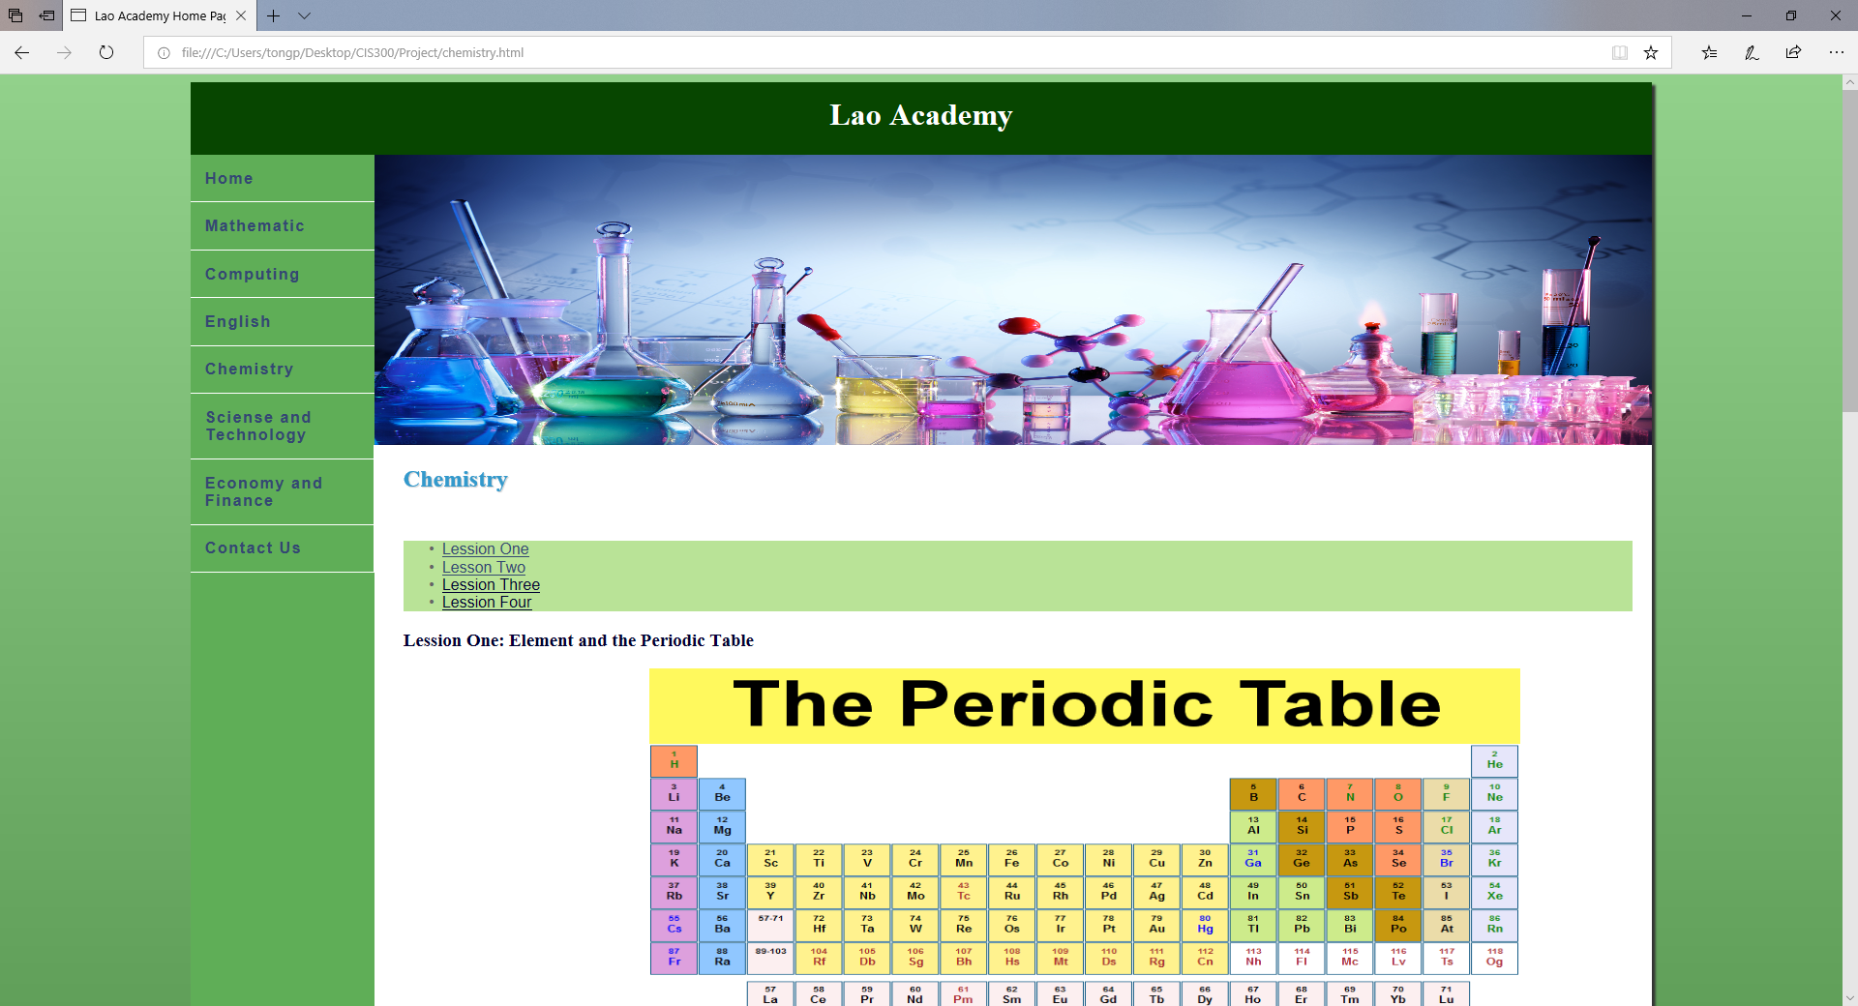

**Web page browser view screenshot of Page #5**

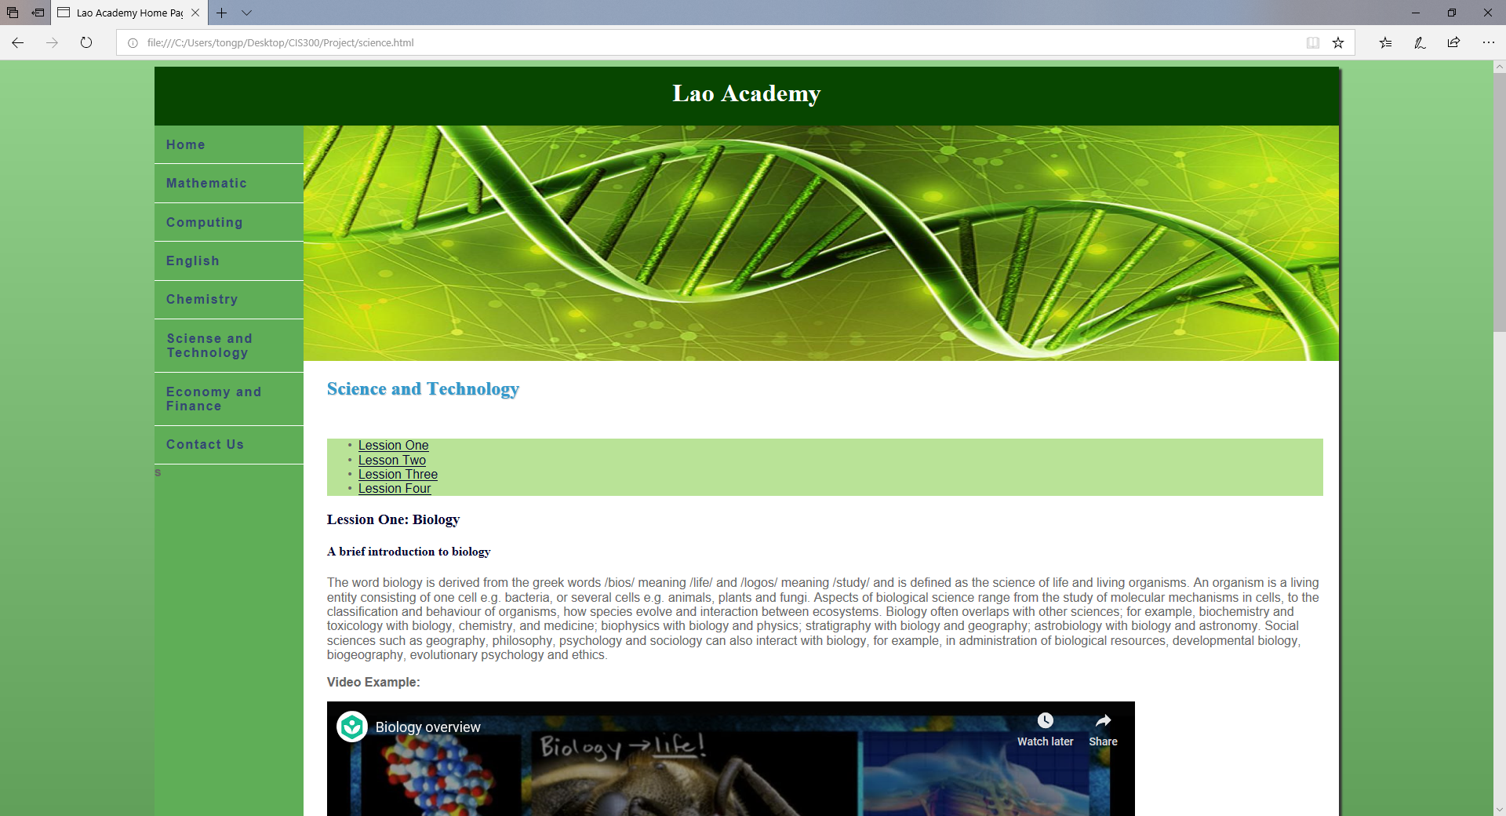

**Web page browser view screenshot of Page #6**

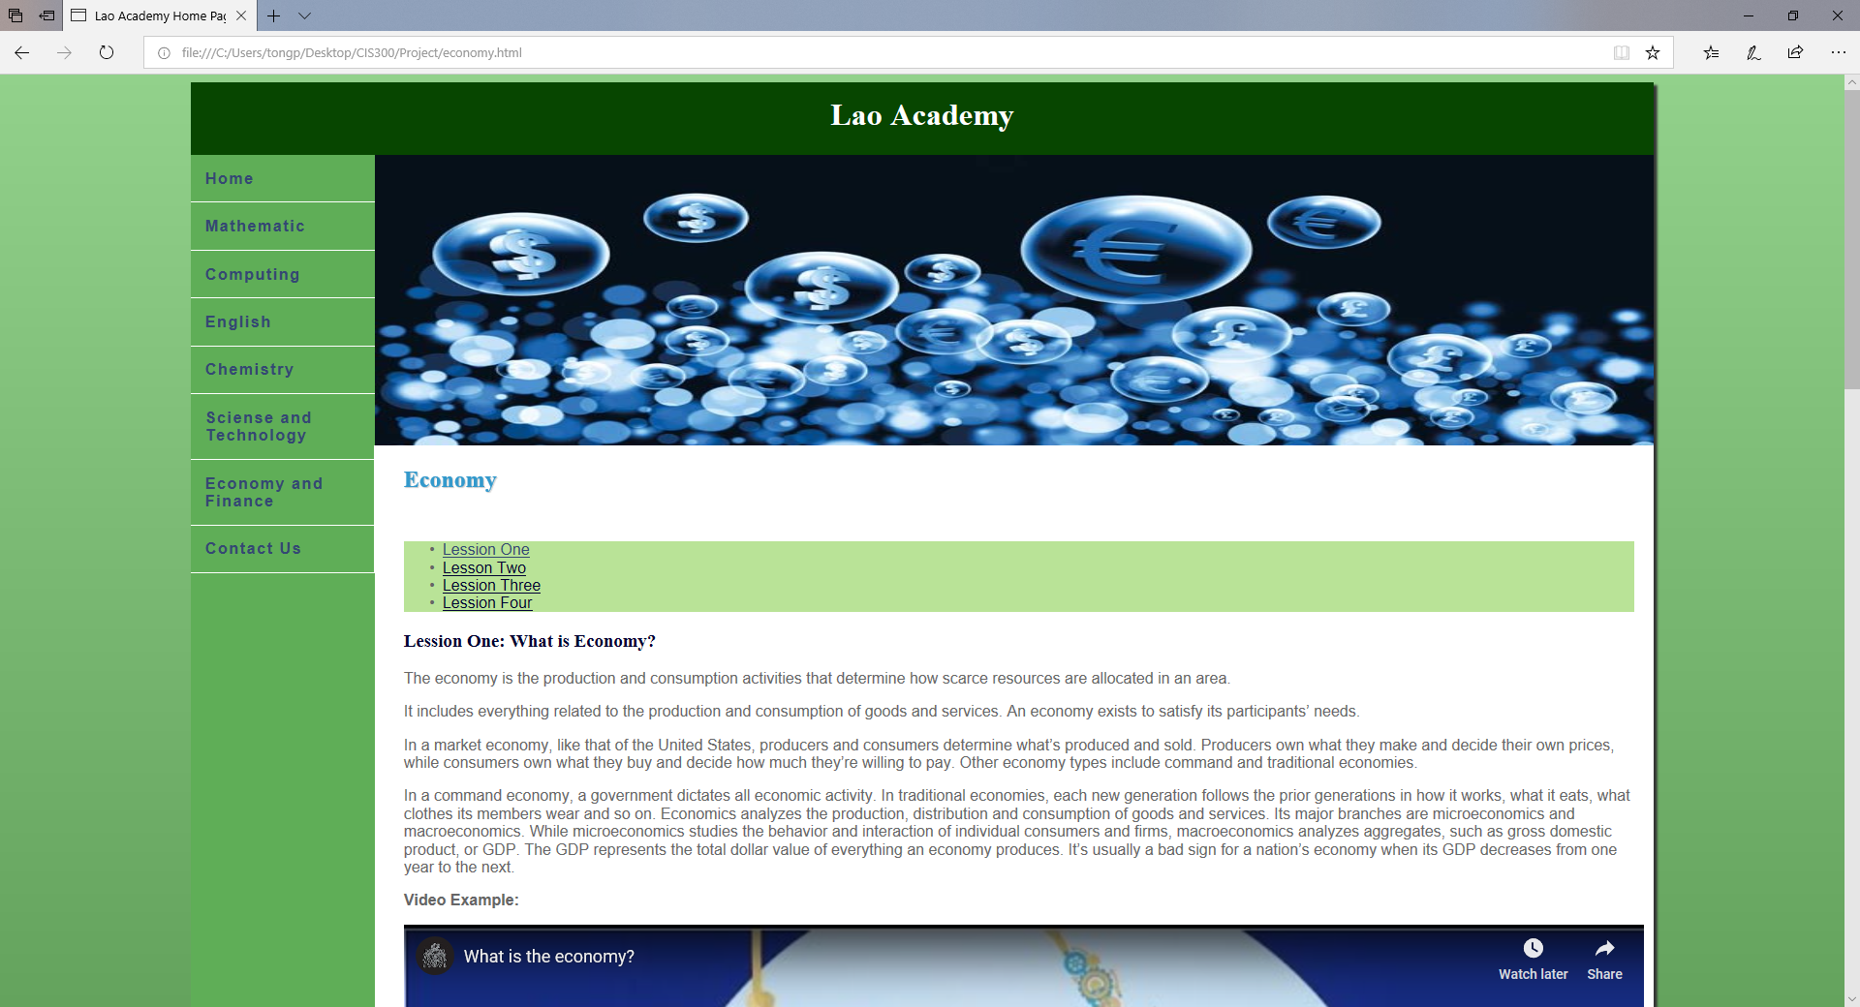

**Web page browser view screenshot of location you used a table**

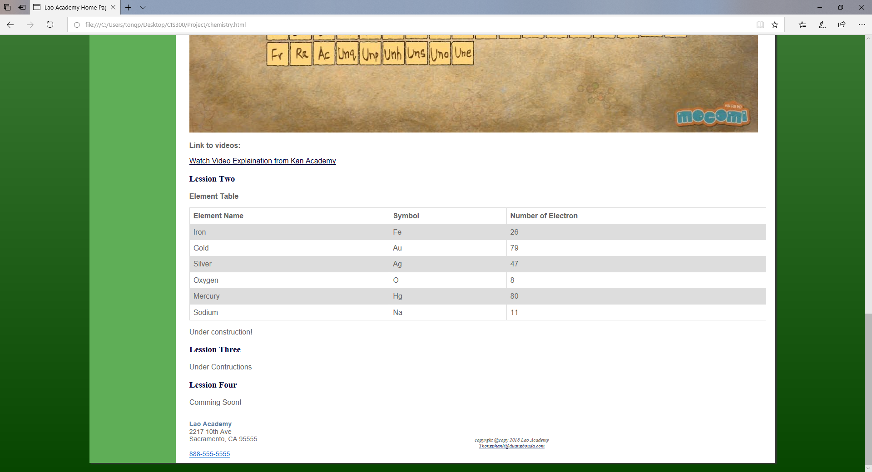

**Web page browser view screenshot of where you used the <video> tag**

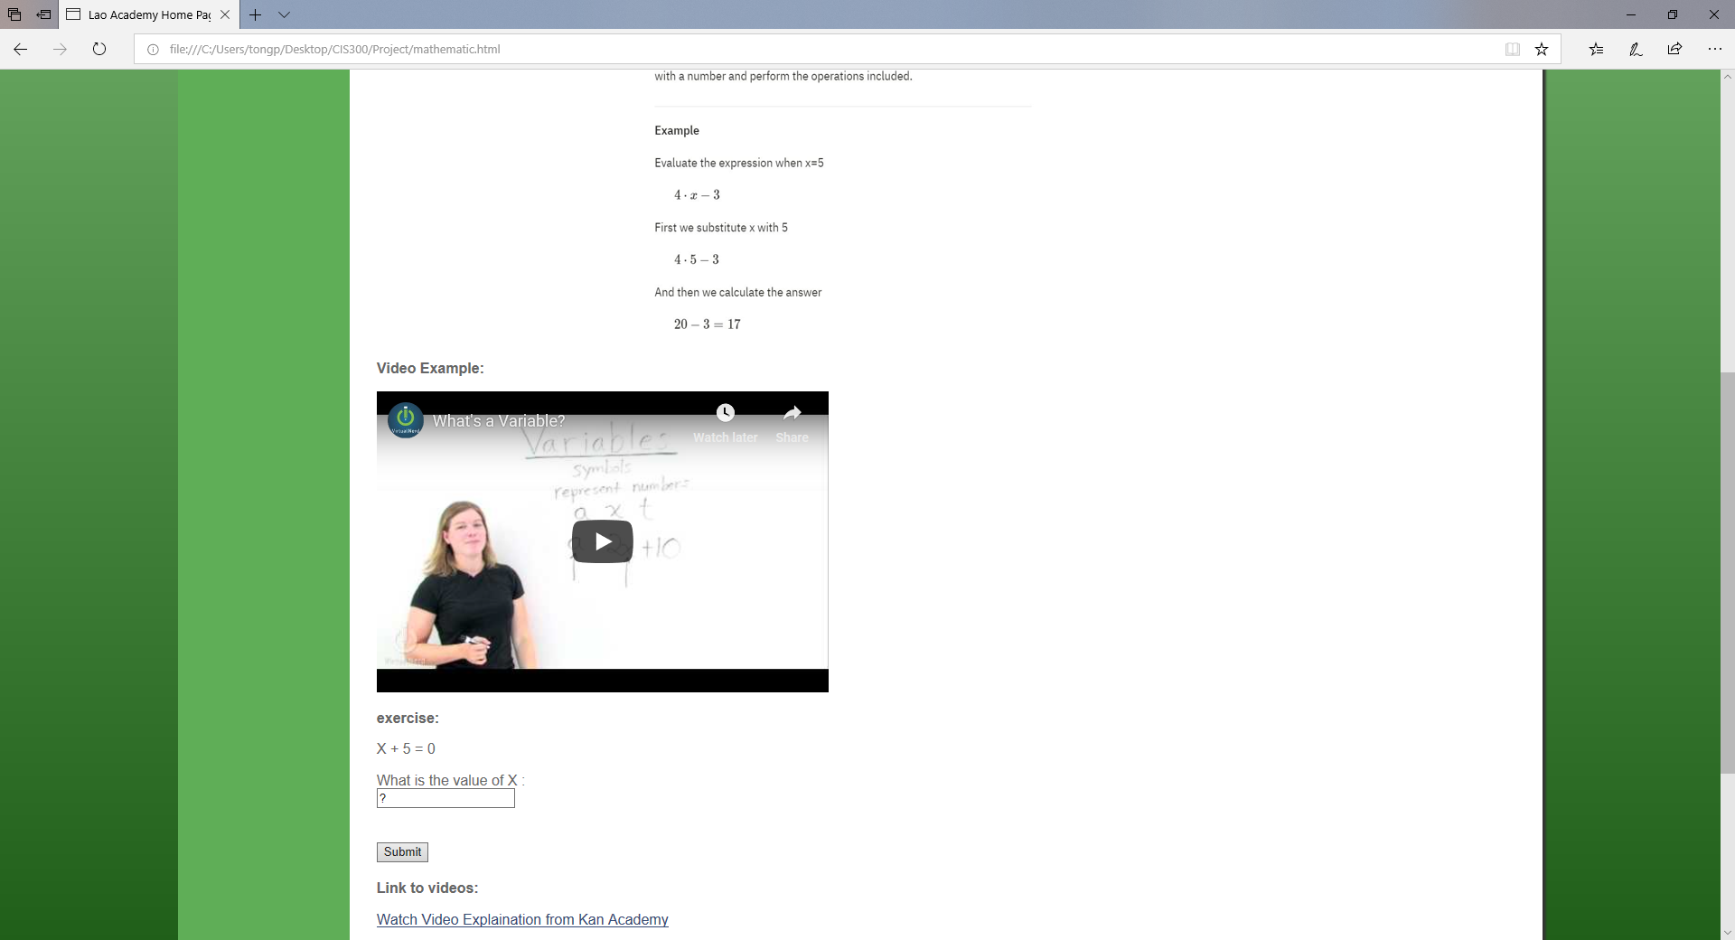

**Web page browser view screenshot of where you used an e-mail link** 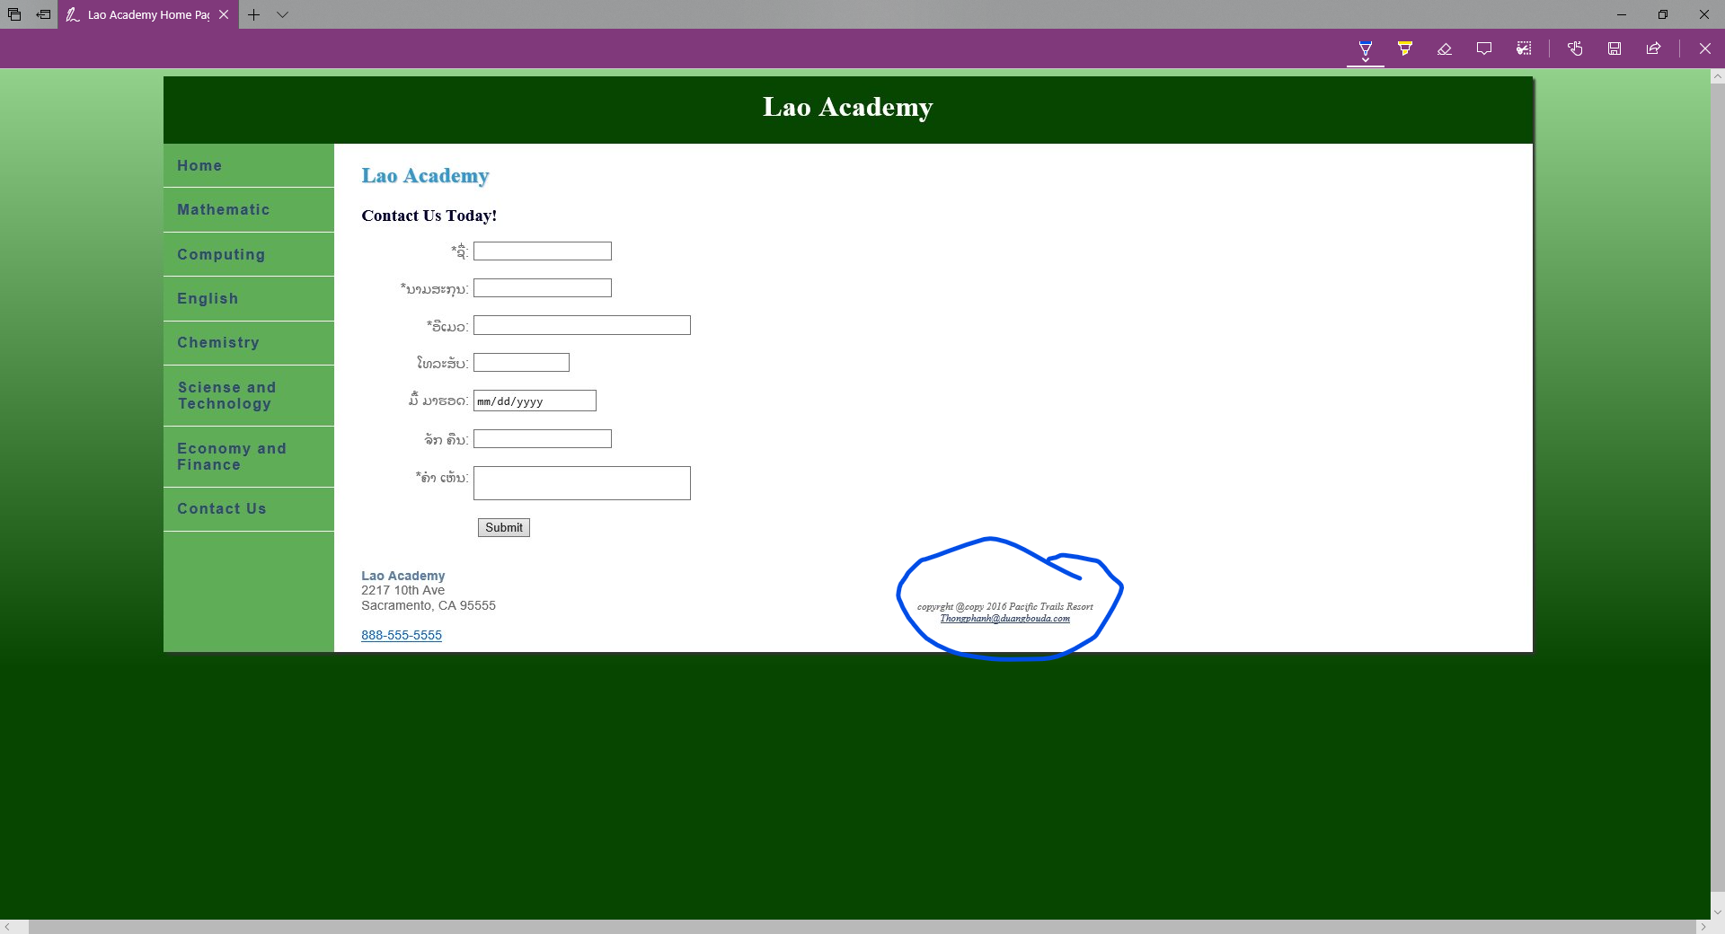

**Web page browser view screenshot of where you used an external link**

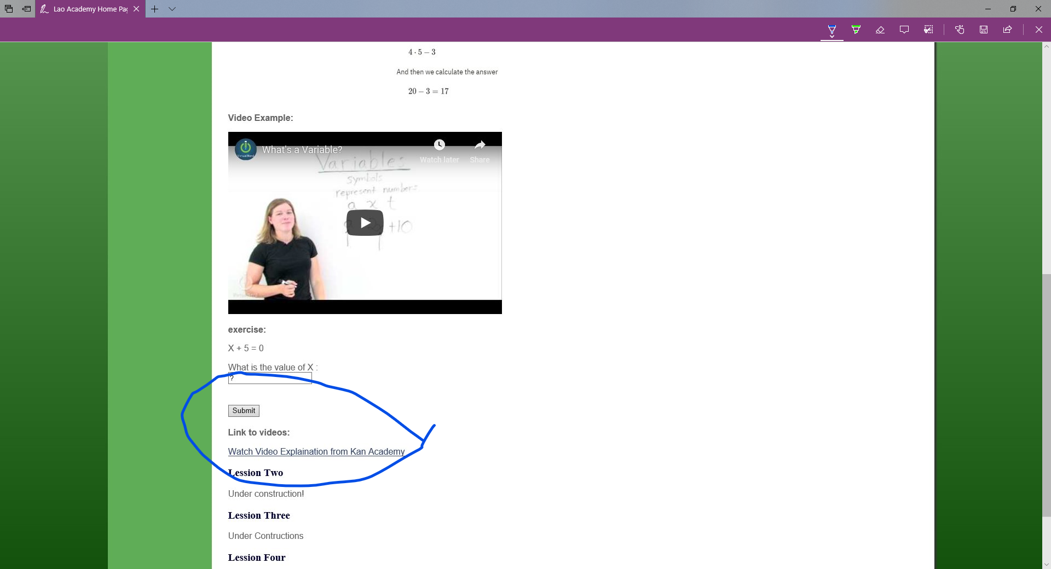

**Web page browser view screenshot of your form**

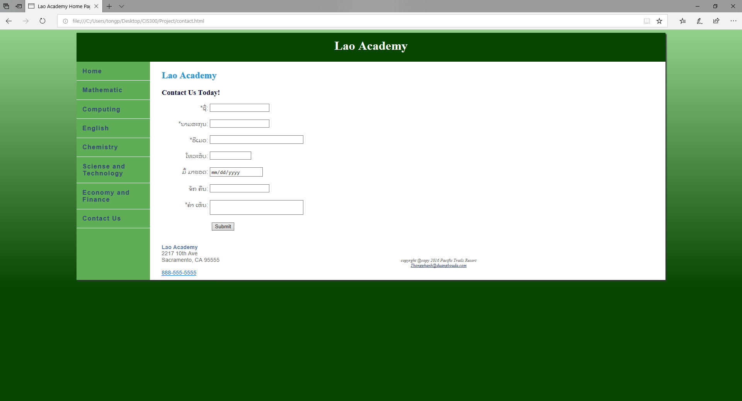

**READY TO SUBMIT? MAKE SURE YOU ZIP/COMPRESS YOUR WHOLE PROJECT FOLDER AND ATTACH BOTH THIS DOCUMENT AND YOUR PROJECT FOLDER.**